|  |
| --- |
| 新东方在线英语学习 |
| 新概念 1 册 |
| Lesson67-68 |



扫一扫。更多有趣的英语资讯。

# Lesson 67 单词讲解

1. greengrocer: n.蔬菜水果零售商
2. grocer, 零售商 ge rou cer

at the greengrocer’s: 在蔬菜水果零售店

at the butcher’s: 在肉店at the doctor’s: 在诊所at the grocer’s: 在零售店

1. absent: adj.缺席的ai bu sent
2. He is absent today.

He is absent from school today. be absent from…

school \ work \ class… She is not absent from work.

1. keep: v.(身体健康)处于(状况) keep healthy 保持健康
2. spend: v. 度过si bai en d
   1. spend + 时间+ 地点

He spends two days in Beijing. He stays in Beijing for two days.

* 1. spend + 时间+ with sb.

He spends two weeks with his girlfriend.

1. weekend: n.周末6.country: n.乡村

in the country 在乡下

in the city 在城里in the village 在村里 国家, in my country

1. lucky: adj.幸运的You are so lucky! You are a lucky dog.
2. Sunday: n. 星期日
3. Monday: n. 星期一
4. Tuesday: n. 星期二tu zi
5. Wednesday: n.星期三wen zi
6. Thursday: n.星期四si er s
7. Friday: n.星期五f ruai
8. Saturday: n.星期六sai der day

# 首字母大写

* 1. **on + 天**

**Lesson 67 课文讲解**

1. at the butcher’s: 在肉店

Were you at the butcher’s? 你刚在肉店吗？

were, 过去式

Are you at the butcher’s? 你现在在肉店吗？

1. How’s Jimmy today? How is…?
2. Was he absent from school last week? be absent from…
3. How are you (all keeping)?
4. We’re going to spend three days in the country. spend + 时间+ 地点
5. at my mother’s 在我妈妈家

at the butcher’s

1. Aren’t you lucky!

你们可真幸运啊！

# Lesson 67 语法讲解

一般过去时态

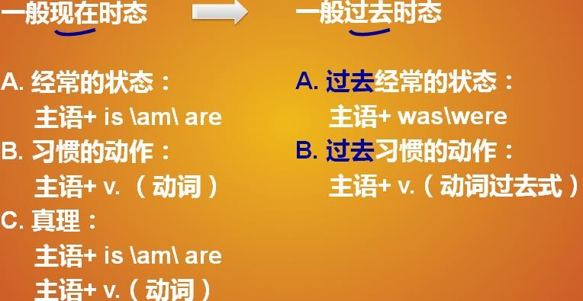

一般过去时态：**主语+was\ were**

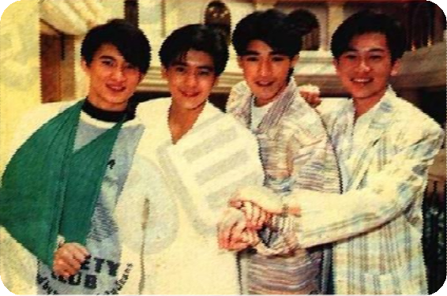

They were young.

我的男朋友 27 岁，他有点胖，

My boyfriend is 27(years old). He is a little fat.

他是个职员，他也在北京。

He is a clerk. He is in Beijing too.

我的男朋友去年 27 岁，当时他有点胖，

My boyfriend was 27(years old) last year. He was a little fat.

他曾经是个职员，两年前他也在北京。

He was a clerk.

He was in Beijing too two years ago.

Who were you?

1. 代表你上辈子是皇宫贵族 (a nobleman )
2. 代表你上辈子是非本地人(not a local )
3. 代表你上辈子是有钱人(a rich man)
4. 代表你上辈子是读书人(an intellectual )
5. 表示你上辈子是武将(a general )
6. 表示你上辈子是非人类 (not human-being)
7. 表示你上辈子是穷人(a poor man)
8. 表示你上辈子天才(a genius)

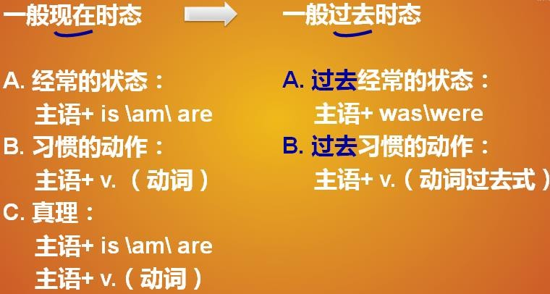

9 表示你上辈子是出家人 (a monk)

I was .

# Lesson 68 单词句型讲解

1. church: n.教堂che er chi
2. at church 在教堂
3. dairy: n.乳品店3.baker: n.面包师傅

at the baker’s 在面包店4.grocer: n.食品杂货商 at the grocer’s 在杂货铺

Where were you on Sunday, Jan. 1st? I was at church.

When were you at the butcher’s?

I was at the butcher’s on Wed, Apr. 4th.

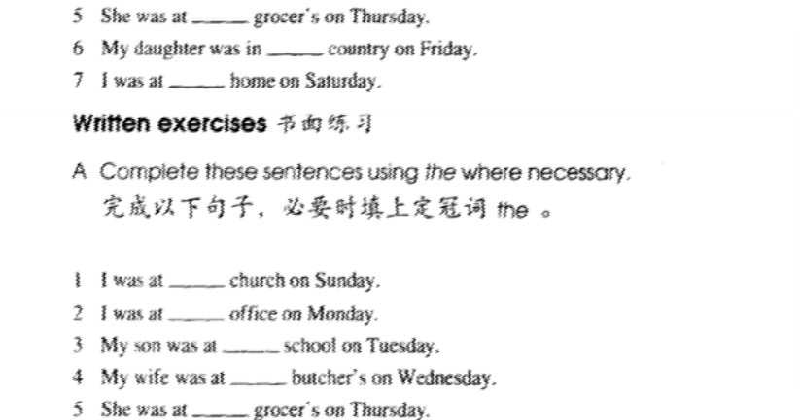

# Lesson 67&68 知识拓展

我也是。

Me too.

* I love Beijing. What about you?
* Me too.
* I don’t love Beijing. What about you?
* Me either.

- My keys are in the car. What about your keys?

* Mine too.
* My favorite sport is swimming. What about you?
* Mine too.